**Components Summary**

*JETSON NANO* – On board Computer (Controller)

*SG90 SERVO MOTOR* – Actuators

*IR Module* – Sensing

*Xbox Kinect v1* – Camera

*ESP32* – Controller or acts a bridge between actuators and jetson nano.

**Jetson Nano**

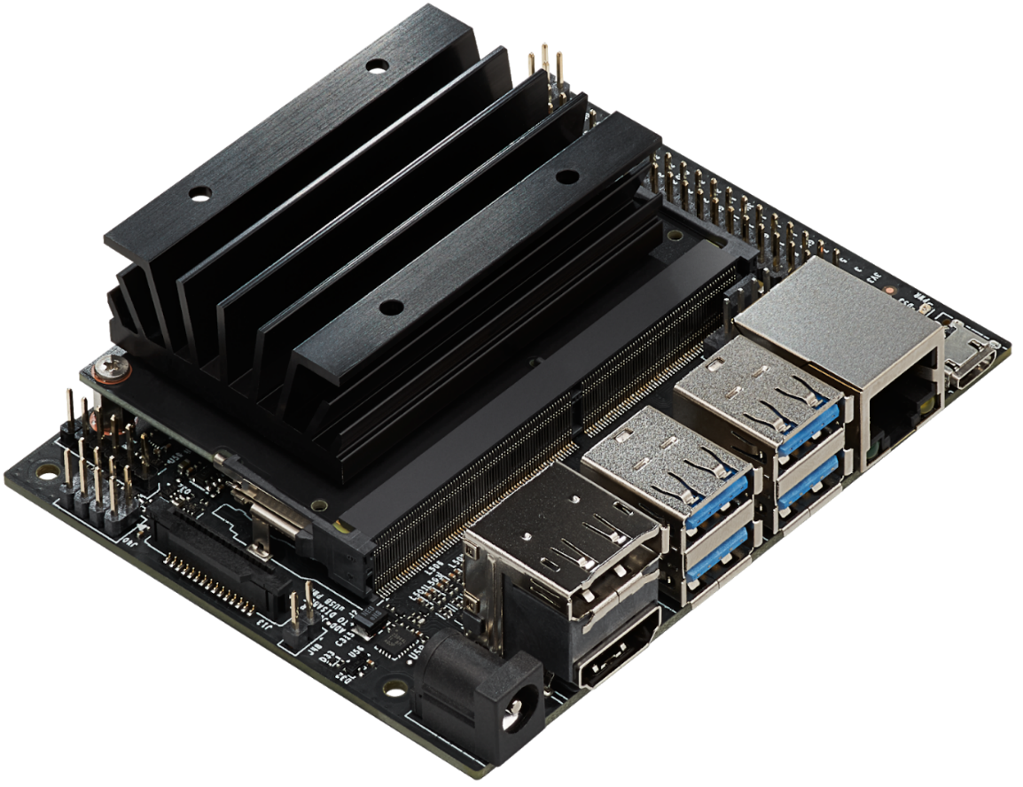

Technical Specifications and Features

Processor:

* CPU: Quad-core ARM Cortex-A57 @ 1.43 GHz.
* GPU: 128-core NVIDIA Maxwell architecture GPU.
* Floating Point Performance: Up to 472 GFLOPS.

Memory and Storage:

* RAM: 4GB 64-bit LPDDR4, 25.6 GB/s bandwidth.
* Storage: microSD card slot for main storage.

Wireless & Connectivity (via expansion or USB):

* Ethernet: Gigabit Ethernet port.
* Wi-Fi and Bluetooth: Not onboard by default, but supported via USB dongle or M.2 module (Jetson Nano 2GB includes Wi-Fi).

Display and Camera:

* Display Output: HDMI 2.0 and DisplayPort 1.2.
* Camera Interface: MIPI CSI-2 (15-pin connector for Raspberry Pi Camera Module v2).

I/O and Expansion:

* USB: 4 × USB 3.0 ports (original model), 1 × USB 2.0 micro-B (device mode), 1 × USB 2.0 (2GB version).
* GPIO: 40-pin expansion header (Raspberry Pi compatible layout).
* Other I/O: I²C, SPI, UART, PWM, and GPIOs.

Power Supply:

* Power Input: 5V via micro-USB or barrel jack (5V⎓4A recommended for full performance).
* Power Modes: Configurable 5W or 10W modes.

Software and Development:

* OS Support: Ubuntu-based JetPack SDK with Linux4Tegra.
* Frameworks: Support for TensorFlow, PyTorch, OpenCV, Keras, Caffe, ROS, and more.
* AI SDKs: Includes NVIDIA DeepStream, CUDA Toolkit, cuDNN, TensorRT.

References

* [Jetson Nano Specifications and Datasheet](https://developer.nvidia.com/embedded/jetson-nano)
* [Jetson Operating System](https://developer.nvidia.com/embedded/develop/software)

**SG90 Servo**

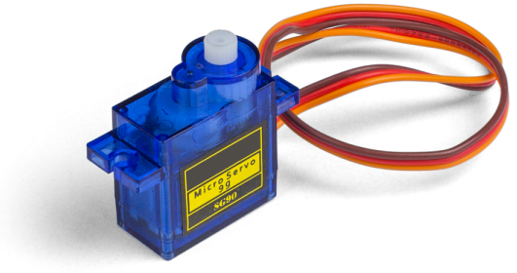

Technical Specifications and Features

Motor Type: SG90 is a 9g micro servo motor with analog control.  
Material: Gear set made from plastic (typically nylon).  
Weight and Dimensions: Weighs about 9g; dimensions approx. 22.5 × 11.8 × 31 mm.  
Operating Voltage: 4.8V to 6.0V (typically 5V).  
Stall Torque:

* At 4.8V: ~1.8 kg·cm
* At 6.0V: ~2.2 kg·cm  
  Operating Speed:
* At 4.8V: ~0.1 s/60°
* At 6.0V: ~0.08 s/60°  
  Rotation Range: ~180°, controlled via PWM signal.  
  PWM Control: Standard 50Hz PWM (20 ms period), where:
* 1 ms pulse ≈ 0°
* 1.5 ms pulse ≈ 90° (neutral)
* 2 ms pulse ≈ 180°  
  Connector: 3-pin female connector (Brown = GND, Red = VCC, Orange = PWM signal).

**References**

* [SG90 Actuator Datasheet](https://www.friendlywire.com/projects/ne555-servo-safe/SG90-datasheet.pdf)
* [SG90 Working](https://www.electronics-lab.com/project/using-sg90-servo-motor-arduino/)

**IR Sensor (LM393)**

Technical Specifications and Features

Sensor Type: Infrared reflective sensor module based on LM393 comparator.  
Functionality: Detects objects or surface contrast by comparing reflected IR light intensity.

**Components**

* Infrared LED (Emitter)
* Photodiode or Phototransistor (Receiver)
* LM393 Comparator IC
* Trimpot (Potentiometer for sensitivity adjustment)
* Indicator LEDs (Power and Output)

**Operating Voltage**

* 3.3V to 5V DC (compatible with microcontrollers like Arduino, Raspberry Pi, ESP32)

**Current Consumption**

* Typically 10–20 mA (may vary slightly depending on module)

**Detection Range**

* Approximately 2 mm to 30 mm
* Most accurate for high contrast surfaces (e.g., black line on white background)

**Output**

* Digital Signal (High/Low logic level)
  + Output Low (0): Object detected (IR reflected)
  + Output High (1): No object detected (no IR reflection)

**Interface**

* Typically 3-pin or 4-pin header:
  + VCC (Power Input)
  + GND (Ground)
  + OUT (Digital Output)
  + EN (Optional Enable Pin in some variants)

**Tuning**

* Sensitivity adjustable via onboard trimpot
* Turning the potentiometer changes the comparator threshold, allowing fine-tuning for different distances or surface reflectivity

**Applications**

* Line-following robots
* Obstacle and edge detection
* Proximity sensors for automation
* Motor speed measurement (with encoder wheel)

**Limitations**

* Limited to short-range detection
* Susceptible to interference from strong ambient infrared sources like sunlight
* Works best in controlled lighting environments

**References**

* [IR Sensor Datasheet](https://adiy.in/shop/ir-sensor-module-with-pot/?srsltid=AfmBOor4Jx69rnmTFdGppe6GSkGGFQ6U-aAsoYLNl0ANHYaVmts_Brbl)
* [IR Sensor Schematics](https://www.elprocus.com/infrared-ir-sensor-circuit-and-working/)

**XBOX Kinect v1**

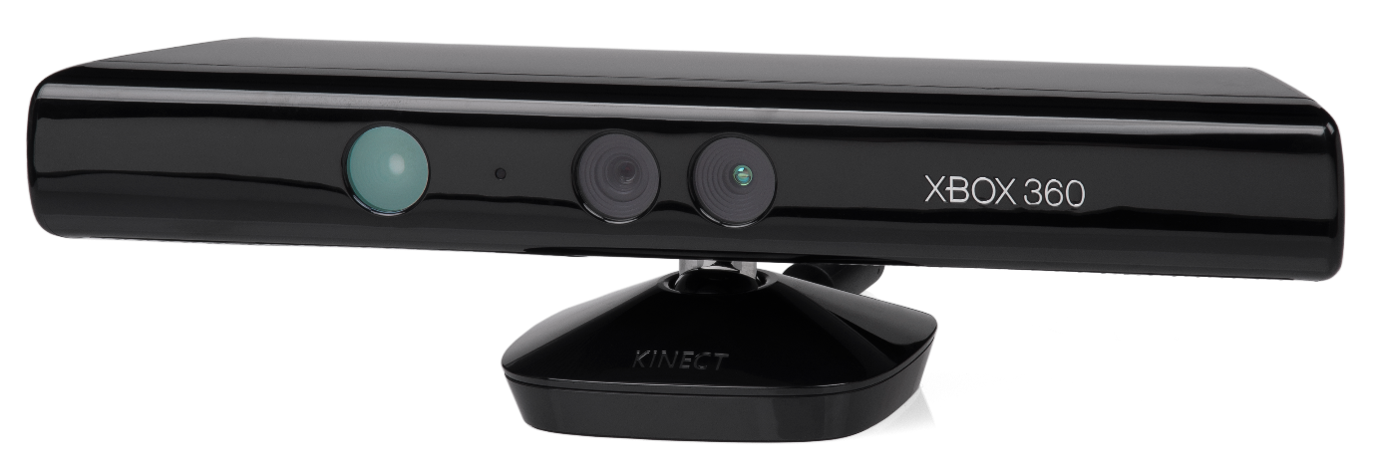

**Technical Specifications and Features**

Sensor Type: RGB-D motion sensing input device developed by Microsoft for Xbox 360 and later used in PC applications.  
Purpose: Captures depth and color data to enable body tracking, 3D scanning, and gesture recognition.

**Components**

* RGB Camera (Color)
* Depth Sensor (IR projector + IR camera)
* Multi-array Microphone (4 microphones)
* Tilt Motor for vertical adjustment
* Accelerometer

**Operating Voltage**

* Requires 12V DC input (via proprietary connector or adapter)
* USB for data connection to host (USB 2.0)

**Power Consumption**

* Approximately 2.5W–5W

**Camera Specifications**

* RGB Camera:
  + Resolution: 640×480 @ 30 FPS (default), up to 1280×1024 via unofficial mods
  + Field of View: ~57° horizontal, ~43° vertical
* Depth Camera:
  + Resolution: 320×240 @ 30 FPS
  + Depth Range: ~0.8 m to 4.0 m
  + Technology: Structured light using IR dot projector

**Microphone Array**

* 4 microphones with beamforming and ambient noise suppression
* Enables voice commands and sound localization

**Motorized Tilt**

* Automatic tilt adjustment of up to ±27°
* Controlled via software commands over USB

**Interface**

* Proprietary connector (Xbox 360) or USB adapter for PC use
* USB 2.0 for data
* Separate power connection (12V)

**Compatibility**

* Xbox 360 (native)
* PC (with Kinect for Windows SDK or OpenNI/NiTE)
* Compatible with Windows, Linux (via OpenNI/libfreenect), and ROS

**Software & SDK**

* Microsoft Kinect SDK (Windows)
* OpenNI & NITE (open-source alternative)
* OpenCV, PCL, and Open3D support for point cloud and image processing

**Applications**

* Gesture and body tracking
* 3D scanning and point cloud generation
* Robotics and SLAM
* Voice recognition and control
* AR/VR prototyping

**References**

* [Develop with Xbox Kinect v1](https://learn.microsoft.com/en-us/archive/msdn-magazine/2012/june/kinect-starting-to-develop-with-kinect)
* [What is Kinect?](https://docs.hidale.com/hardware/sensors/kinect-v1)

**ESP32**

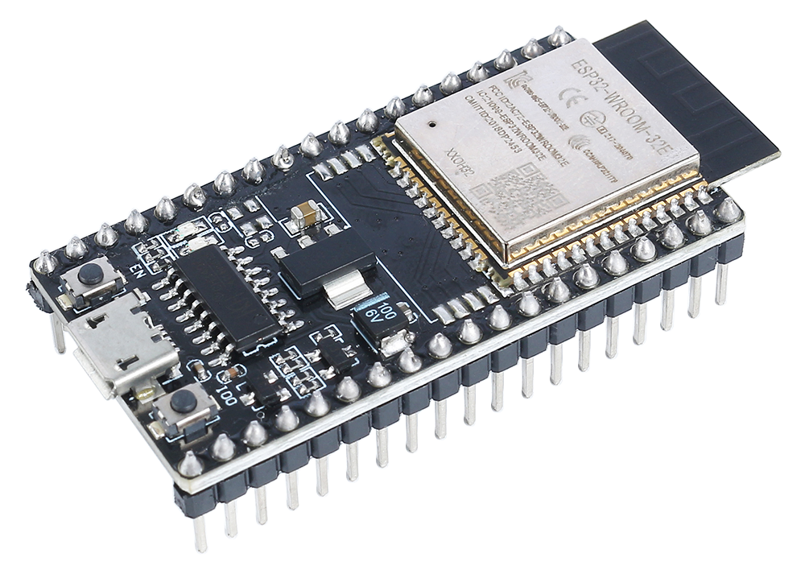

**Technical Specifications and Features**

Microcontroller: ESP32 — a low-power system-on-chip (SoC) microcontroller with integrated Wi-Fi and Bluetooth, developed by Espressif Systems. It is widely used in IoT, robotics, and embedded systems projects.

**Processor**

* Dual-core Xtensa® 32-bit LX6 microprocessor (can also be configured as single-core)
* Clock Speed: up to 240 MHz
* Performance: up to 600 DMIPS
* Ultra-low-power co-processor for sensor monitoring during sleep

**Memory**

* SRAM: 520 KB
* ROM: 448 KB
* External Flash Support: Up to 16 MB (typically 4MB in Dev Boards)

**Connectivity**

* Wi-Fi: IEEE 802.11 b/g/n
* Bluetooth: v4.2 BR/EDR and BLE
* Ethernet MAC Interface
* SPI, I²C, I²S, UART, CAN

**GPIO**

* Total GPIO Pins: 34
* Most pins support PWM, ADC, DAC, SPI, I²C, UART
* 12-bit SAR ADC (up to 18 channels)
* 2 × 8-bit DAC
* Capacitive Touch: 10 inputs
* Hall Sensor and Temperature Sensor built-in

**Timers and PWM**

* 4 × 64-bit Timers
* 2 × 32-bit Timers
* PWM for up to 16 channels (LEDC)

**Power Supply**

* Operating Voltage: 2.2 V to 3.6 V (typically 3.3V)
* Deep Sleep Current: <5 μA
* Power Modes: Active, Modem Sleep, Light Sleep, Deep Sleep, Hibernation

**Storage**

* SPI Flash (external): 4 MB to 16 MB (depending on board)
* Optional microSD card support via SPI

**Security**

* Hardware acceleration for encryption (AES, SHA-2, RSA, ECC, etc.)
* Secure boot and Flash encryption
* Random Number Generator

**Development and Programming**

* Programming Interfaces: USB-UART, JTAG
* Programming Languages: C/C++ (Arduino IDE, ESP-IDF), MicroPython, Lua
* Tools & SDKs:
  + Arduino Core for ESP32
  + Espressif IDF (official SDK)
  + PlatformIO

**Dimensions (Common Dev Boards)**

* ESP32 DevKit v1: ~51mm × 25mm
* NodeMCU-32S: ~48mm × 25mm

**Applications**

* IoT Devices and Home Automation
* Wireless Sensor Networks
* Wearables
* Robotics and Drones
* Smart Agriculture
* Voice Assistants (ESP32-LyraT)

**Limitations**

* 3.3V logic (not 5V tolerant)
* Some GPIOs have specific boot functions — care needed during design
* High-frequency operations may require attention to power and grounding

**References**

* [Espressif Official Datasheets and Technical Reference Manual](https://docs.espressif.com/projects/esp-dev-kits/en/latest/esp32/esp32-devkitm-1/user_guide.html#getting-started)
* [ESP32 DevKit v1 Schematic](https://dl.espressif.com/dl/schematics/esp32_devkitc_v4-sch.pdf)

**CONNECTION DIAGRAM**

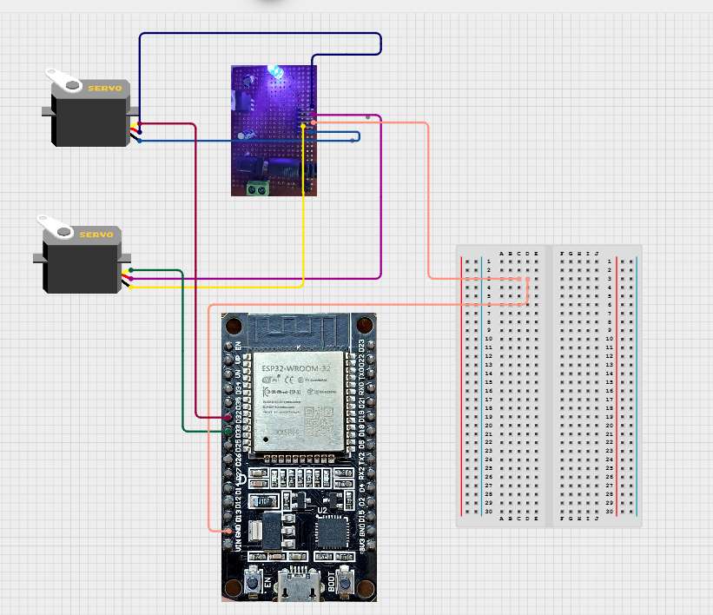

This is the connection laid between the *ESP32* two servos (used one instead of two in the project), the servos are powered through a buck convertor and a common ground is established between the buck convertor and *ESP32* microcontroller. The buck convertor is used to convert 12v to 5v.

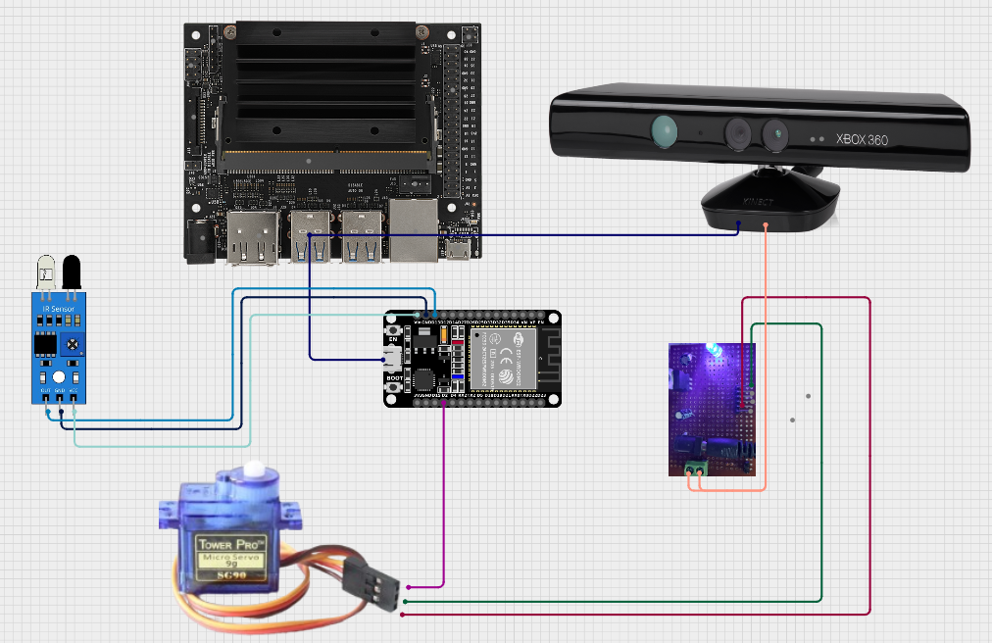

The above diagram shows the entire connection between the *Jetson* board and the actuation system which consists of the IR sensor, *SG90* Servo. The IR senses and control the movement of the actuator while the *Kinect* effectively maps the space.